Chapter 03: Software Requirement Analysis and
Specification
3.1. System Requirements:
More detailed descriptions of system functions, services and constraints than user requirements.
• They are intended to be a basis for designing the system.
• They may be incorporated into the system contract.
• System requirements specification may include different models of the
system.
– E.g. Object model, data-flow model
Requirements and design:
- In principle, requirements should state what the system should do and the design should describe how it does this.
- In practice, requirements and design are inseparable
– A system architecture may be designed to structure the requirements;
– The system may inter-operate with other systems that generate design
requirements;
– The use of a specific design may be a domain requirement.

3.2. Software Requirements:
What is a requirement?
- It may range from a high-level abstract statement of a service or of a system constraint to a detailed mathematical functional specification.
- This is inevitable as requirements may serve a dual function
- May be the basis for a bid for a contract - therefore must be open to
interpretation;
- May be the basis for the contract itself - therefore must be defined in
detail;
- Both these statements may be called requirements.

Software specification:

- The process of establishing what services are required and the constraints on the system’s operation and development
- Also known as Requirements engineering
- Consists of four main phases
- Feasibility (technical and otherwise) study
- Requirements elicitation and analysis
- Requirements specification (documentation)
- Requirements validation

The Requirements engineering process:
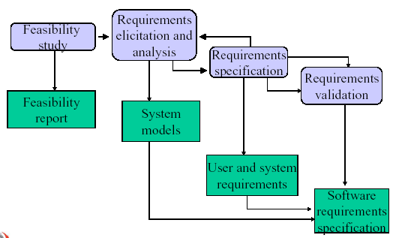

Requirements Engineering Process:
- Feasibility Study
- A feasibility study is a short, focused study which aims to check the feasibility of the project considering resources, cost/benefit, technology availability etc.
- A feasibility study decides whether or not the proposed system is worthwhile.
- A short focused study that checks
- If the system contributes to organisational objectives
- If the system can be engineered using current technology and within
budget
- If the system can be integrated with other systems that are used
- Based on information assessment (what is required), information collection and report writing.
Questions for people in the organisation
- What if the system wasn’t implemented?
- What are current process problems?
- How will the proposed system help?
- What will be the integration problems?
- Is new technology needed? What skills?
- What facilities must be supported by the proposed system?
- Requirement elicitation and analysis
In this activity, technical software development staff works with customers and system end-users to find out about the application domain, what services the system should provide, the required performance of the system, hardware constraints and so on.
- Requirements specification:
A detailed and precise description of the system requirements is set out to act as a basis for a contract between client and software developer.
- Requirements validation:
In this activity, checks should be carried out to make sure that the requirements are accurate and complete. It is necessary to check the correctness of the specification of requirements.

Requirements Documents:
User requirements (Requirements definition):
These are statements in a natural language plus diagrams, of what services the system is expected to provide and constraints under which it must operate.
System requirements:
The system services and constraints in detail. This is detailed functional specification. It may serve as a contract between the system buyer and the software developer.
Software Requirements Specification (SRS):
A detailed and technical specification of the requirements. This is the basis for design and implementation. This is an abstract description of the software.
Readers of Requirements Documents:
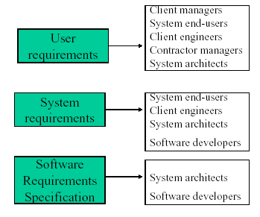

An Example:
User Requirements Definition:
The software must provide a means of representing and accessing external files created by other tools.
System requirements specification:
- The user should be provided with facilities to define the type of external files.
- Each external file type may have an associated tool which may be applied to the file.
- Each external file type may be represented in a specific icon on the user’s display.
- Facilities should be provided for the icon representing an external file type to be defined by the user.

Type of Requirements:
Functional Requirements:
These are statements of services the system should provide, how the system should react to particular inputs and how the system should behave in particular situations.
Non-functional Requirements:
These are constraints on the services or functions offered by the system.
Domain Requirements:
These are requirements that come from the application domain of the system and that reflect characteristics of the domain.
Functional Requirements:
- Describe functionality or services that the system is expected to provide.
- Depend on the type of software, expected users and the type of system where the software is used.
- Functional user requirements may be high-level statements of what the system should do but functional system requirements should describe the system services in detail.
Example:
Some functional requirements of a university library system.
  - The user should be able to search for a library item by specifying a key word.

  - The library staff member should be able to issue a library item by scanning the bar codes of the library item and the student card.
  - Students can reserve a library item on line.

Examples of functional requirements
- The user shall be able to search either all of the initial set of databases or select a subset from it.
- The system shall provide appropriate viewers for the user to read documents in the document store.
- Every order shall be allocated a unique identifier (ORDER_ID) which the user shall be able to copy to the account’s permanent storage area.
Requirements imprecision:
  - Problems arise when requirements are not precisely stated.
  - Ambiguous requirements may be interpreted in different ways by developers and users.
– E.g. Consider the term ‘appropriate viewers’
* User intention - special purpose viewer for each different document
type.
* Developer interpretation - Provide a text viewer that shows the
contents of the document.

Non-functional requirements:
- These define system properties and constraints
– System Properties: reliability, response time and store occupancy.
Constraints: I/O device capability, data representations used in system interfaces.
- More critical than functional requirements. If these are not met, the system is useless.
- Relate to the system as a whole rather than to individual system features.
- Not always concerned with the software system to be developed.
- Constrain the process which may be used to develop the system.
- Non-functional requirements arise through user needs, because of
– Budget constraints
– Organizational policies
– The need for interoperability with other s / w and h / w systems
– External factors e.g. safety regulations
Non-functional Requirements Classification:
Product Requirements
- Performance requirements
- Reliability
- Portability
- Interface requirements

Organizational Requirements
- Delivery requirements
- Implementation requirements
- Standards requirements

External requirements
- Interoperability requirements
- Ethical requirements
- safety requirements

Examples:
Product requirement:-
The system should be easy to use by non-experienced users and hence should provide a graphical user interface.

Organizational requirement:-
The system development process and deliverable documents shall confirm to the process and deliverables defined in ISO 9000.

External requirement:-
The system shall not disclose and personal information about customers apart from their name and reference number to the operators of the system.

- Non-functional requirements may be very difficult to state precisely and imprecise requirements may be difficult to verify.
- May be written to reflect the goals of the customer.
– Goal
• A general intention of the user such as ease of use.
• Goals are helpful to developers as they convey the intentions of the
system users.
- Verifiable non-functional requirement
– A statement using some measure that can be objectively tested.
Examples:-
A system goal
– The system should be easy to use by experienced controllers and should
be organized in such a way that user errors are minimized.

A verifiable non-functional requirement
    - Experienced controllers shall be able to use all the system functions after a total of two hours training. After this training, the average number of errors made by experienced users shall not exceed two per day.
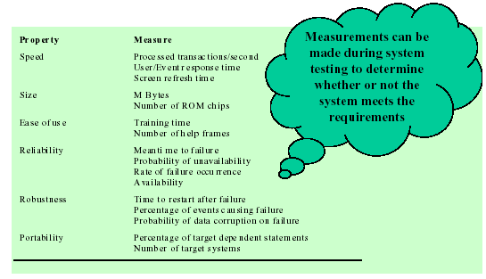
Requirements measures:

Requirements interaction:
Conflicts between different non-functional requirements are common in complex systems.
Spacecraft system
– To minimize weight, the number of separate chips in the system should be minimized.
– To minimized power consumption, lower power chips should be used.
– However, using low power chips may mean that more chips have to be used. Which is the most critical requirement?

Domain requirements:
Domain requirements are derived from the application domain of the system rather than from the specific needs of the system users. They may be new functional or non- functional requirements in their own right, constrain existing requirements or set out how particular computation must be carried out.
Examples
- Because of copyright restrictions, some documents must be deleted immediately on arrival. Depending on the users requirements, these documents will either be printed locally on the system server for manually forwarding to the user or routed to a network printer.

- There shall be a standard user interface to all databases which shall be based on the Z39.50 standard.

Domain requirements problems:
• Understand-ability
– Requirements are expressed in the language of the application domain;
– This is often not understood by software engineers developing the system.
• Implicitness
– Domain specialists understand the area so well that they do not think of making the domain requirements explicit.
External behavior of the System AVOID system design characteristics

User requirements:

• Should describe functional and non-functional requirements in such a way that they are understandable by system users who don’t have detailed technical knowledge.
• User requirements are defined using natural language, tables and diagrams as these can be understood by all users.
• Should not be defined using an implementational model.

3.3 Requirement Elicitation and Analysis of Requirements:

Elicitation and Analysis:

Sometimes called requirements elicitation or requirements discovery.

Involves technical staff working with customers to find out about the application domain, the services that the system should provide and the system’s operational constraints.

May involve end-users, managers, engineers involved in maintenance, domain experts, trade unions, etc. These are called stakeholders.

Problems of requirements analysis:
- Stakeholders don’t know what they really want.
- Stakeholders express requirements in their own terms.
- Different stakeholders may have conflicting requirements.
- Organizational and political factors may influence the system requirements.
The requirements change during the analysis process. New stakeholders may emerge and the business environment change.

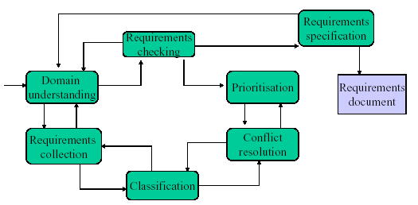
The requirements elicitation and analysis process:

Requirement Analysis Tools:
- Traditional structured methods (P+D)
- Entity relationship diagrams (ERD)
- Data Flow Diagrams (DFDs)
- Entity State Transition diagrams

Object oriented methods (O-O):
- Use Case Diagrams
- Class Diagrams
- Sequence Diagrams
- State Transition Diagrams

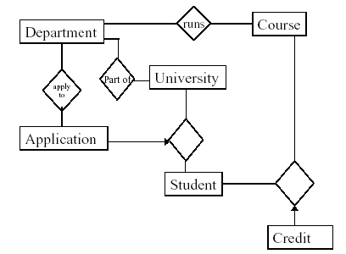
Entity Relationship Diagrams:

Data Flow Diagrams Context Diagram:
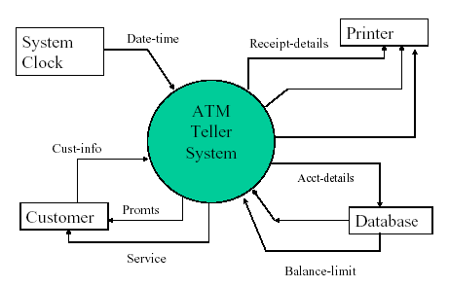

A First Level DFD
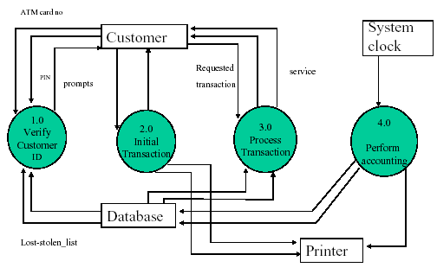

Process specification
Internal Specification
• Pseudo code specification
• Decision Tables
External specification
• Pre-condition-Post condition

Process specification - Pseudo code:
Verify customer ID (DFD process 1.0)
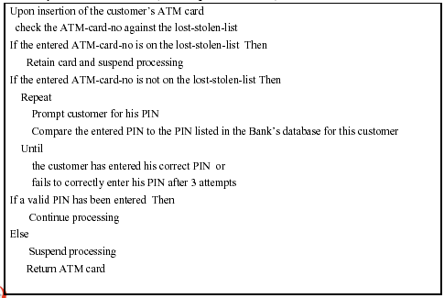

Process specification - Decision Table:
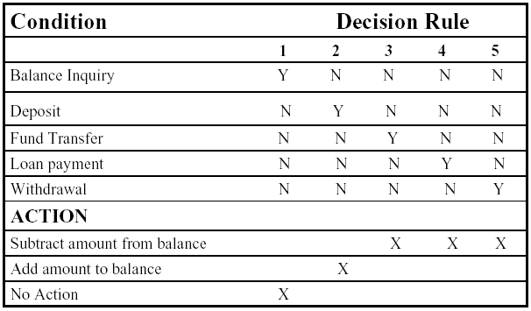
Calculate new balances (DFD Process 4.1)

Process specification - An External specification:
pre-condition – what must be true for the function to execute correctly
post-condition - What is guaranteed to be true after the function executes
Example : A merge function may be specified as follows
merge(item1:array,item2 : array) : newArray
PreSizeOf (item1)>0, SizeOf(item2)>0, (both arrays have at least one element)
item1[i] <item1[i+1], 1<i<noOfitems1 (in order)
item2[i] <item2[i+1], 1<i<noOfitems2 (in order)
PostSizeOf(newArray)=SizeOf(item1) + SizeOf(item2)
newArray[i] < newArray[i+1], 1<i<SizeOf(newArray)
These are all testable

Data Specification:
All data flows in DFDs should be specified using a combination of elementary data flows or previously defined data flows.
The following symbols can be used in dataflow specifications
And +
Or []
Repeat {}
Optional ()
Comment **
Examples:
Acct-designation = 1{alphanumeric-character}15
Acct-number = 8{numeric-character}8
Amount = rupees+cents
Acct-selection = [savings/checking/loan-acct/credit-card]
(acct-designation)
Cust-acct-list = 1{acct-designation+acct-number}8
Balance-display = * display of current balance to customer*
Requirement Specification practice– Good
Use a form based approach
* Describe each function in separate form
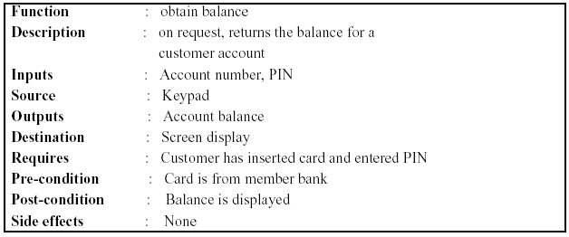

A Use-case Diagram:

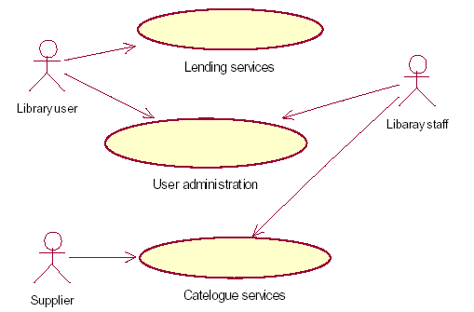

Use-cases are a scenario-based technique for requirements elicitation which were first introduced in the Objectory methods (Jacobson et at 1993).

A Class Diagram:
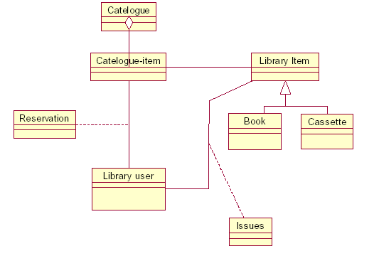

Sequence Diagrams:

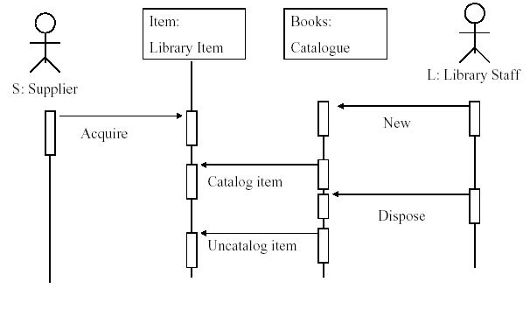

Non-functional Requirements:
Define system properties and constraints Eg: reliability, performance, interface, security, storage requirements.
Process requirements may also be specified mandating a particular CASE system, programming language or development method.
Non-functional requirements may be more critical than functional requirements. If these are not met, the system is useless.
Requirements verifiability
Requirements should be written so that they can be objectively verified.
The problem with this requirement is its use of vague terms such as ‘errors should be minimized’
Experienced controllers should be able to use all the system functions after a total of two hours training. After this training, the average number of errors made by an experienced users should not exceed two per day.

Non-functional Requirements measures:
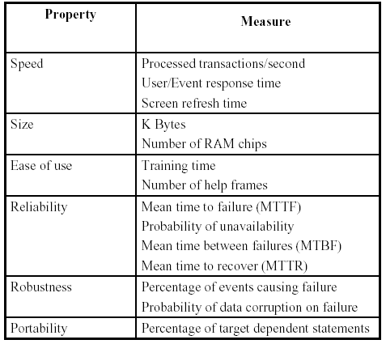

Software Requirements Document - IEEE standard:
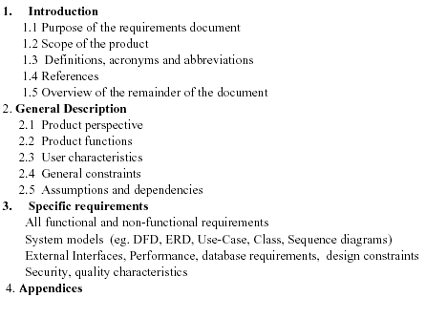

Requirement Evolution:
Over the time, the systems environment and the business objectives will almost certainly changed. The requirements must therefore evolve to reflect this.
From an evolution perspective, requirements fall into two classes:
- Enduring requirements: These are relatively stable requirements which derive from the core activity of the organization and which relate directly to the domain of the system.
- Volatile requirements: These are requirements which are likely to change during the system development or after the system has been developed.

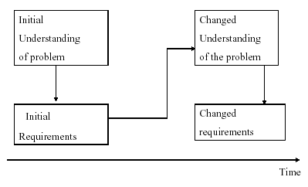

Controlled Evolution of Requirements:

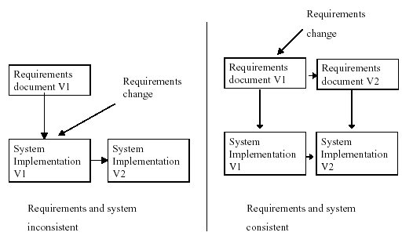

Requirements Validation:
- Requirements validation is concerned with showing that the requirements actually define the system which the customer wants.
- Requirements validation is important because errors in a requirements document can lead to extensive rework costs when they are subsequently discovered during development or after the system is in service.

Requirements Validation – Checks:
  - Validity checks - Systems have diverse users with different needs and any set of requirements is inevitably a compromise across the user community.
  - Consistency checks - Requirements in a document should not conflict.
  - Completeness checks – The requirements document should include requirements which define all functions and constraints intended by the system user.
  - Realism checks - Using knowledge of existing technology, the requirements should be checked to ensure that they can actually be implemented.
  - Verifiability - The requirements should be given in verifiable manner (eg; Using quantifiable measures) to reduce the potential for dispute between customer and developer.

Requirements Validation – Techniques:
- Reviews - The requirements are analalysed systematically by a team of reviewers.
- Prototyping - In this approach to validation, an executable model of the system is demonstrated to end-users and customers. They can check whether the requirements satisfy their needs.
- Test-case generation - Requirements should ideally be testable. If a test is difficult or impossible to design, this usually means that the requirements will be difficult to implement and should be reconsider.
- Automated consistency analysis: If the requirements are expressed as a system model in a structured or formal notation than CASE tools may be used to check the consistency of the model.

